**LMS Database Design**

1. 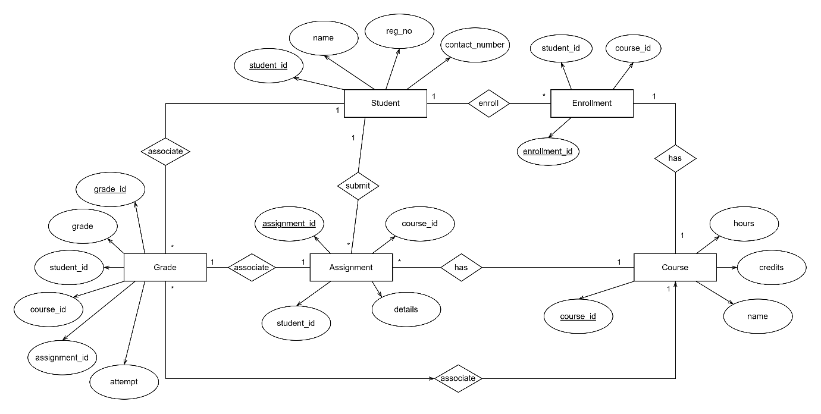**ER Diagram**

Tables:

Student

|  |  |
| --- | --- |
| **Columns** | **Data Type** |
| Student_id | int (primary key) |
| Name | Varchar (255) |
| Reg_no | Varchar(255) |
| Contact_no | Varchar(255) |

Course

|  |  |
| --- | --- |
| **Columns** | **Data Type** |
| Course_id | int (primary key) |
| Name | Varchar (255) |
| Credits | int |
| Hours | int |

Assignment

|  |  |
| --- | --- |
| **Columns** | **Data Type** |
| Assignment_id | int (primary key) |
| Course_id | int (foreign key) |
| Student_id | int (foreign key) |
| Details | text |

Grade

|  |  |
| --- | --- |
| **Columns** | **Data Type** |
| Grade_id | int (primary key) |
| Student_id | int (foreign key) |
| Assignment_id | int (foreign key) |
| Course_id | int (foreign key) |
| Grade | Varchar(2) |
| Attempt | int |

Enrollment

|  |  |
| --- | --- |
| **Columns** | **Data Type** |
| Enrollment_id | int (primary key) |
| Student_id | int (foreign key) |
| Course_id | int (foreign key) |

Assumptions made:

* A course examination can be attempted multiple times where grades have to be stored multiple times, and hence the column attempt is introduced.
* An assignment would only be graded once

**SQL Queries**

1. List all students enrolled in a specific course.

SELECT * FROM Student INNER JOIN Enrollment ON Enrollment.Student_id = Student. Student_id WHERE Enrollment.Course_id = 1

// Assuming the specific course id is 1

1. Insert grades for a particular assignment.

INSERT INTO Grade(Student_id, Assignment_id, Course_id, “Grade”, “Attempt”) VALUES (1, 1, 1, “B-“, 1);